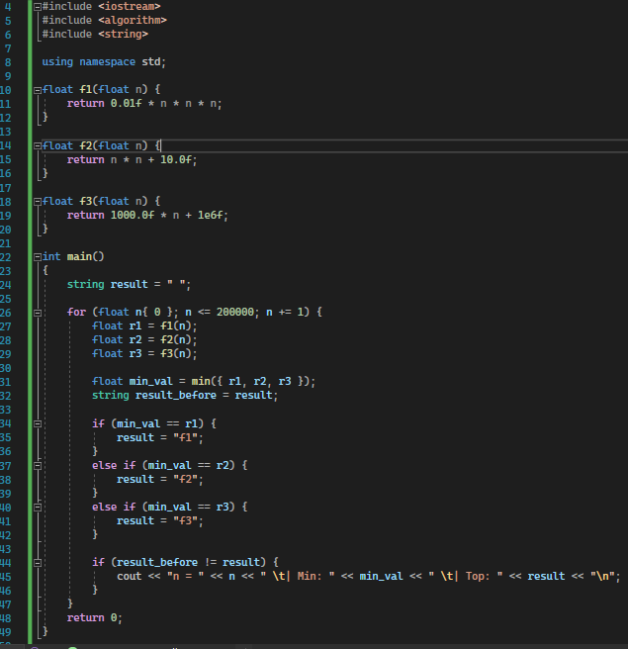
#include <iostream>
#include <algorithm>
#include <string>

using namespace std;

float f1(float n) {
return 0.01f * n * n * n;
}

float f2(float n) {
return n * n + 10.0f;
}

float f3(float n) {
return 1000.0f * n + 1e6f;
}

int main()
{
string result = " ";

for (float n{ 0 }; n <= 200000; n += 1) {
float r1 = f1(n);
float r2 = f2(n);
float r3 = f3(n);

float min_val = min({ r1, r2, r3 });
string result_before = result;

if (min_val == r1) {
result = "f1";
}
else if (min_val == r2) {
result = "f2";
}
else if (min_val == r3) {
result = "f3";
}

if (result_before != result) {
cout << "n = " << n << " \t| Min: " << min_val << " \t| Top: " << result << "\n";
}
}
return 0;
}
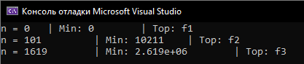

n = 0 | Min: 0 | Top: f1
n = 101 | Min: 10211 | Top: f2
n = 1619 | Min: 2.619e+06 | Top: f3

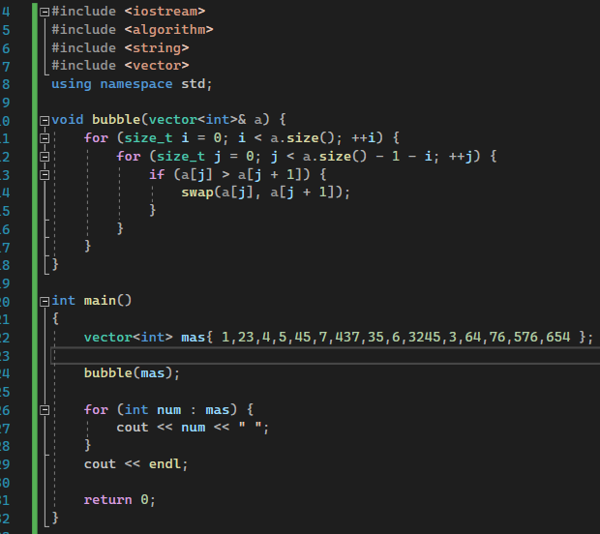
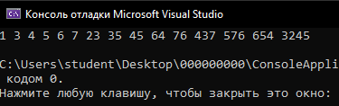
Сложность O(n^2)
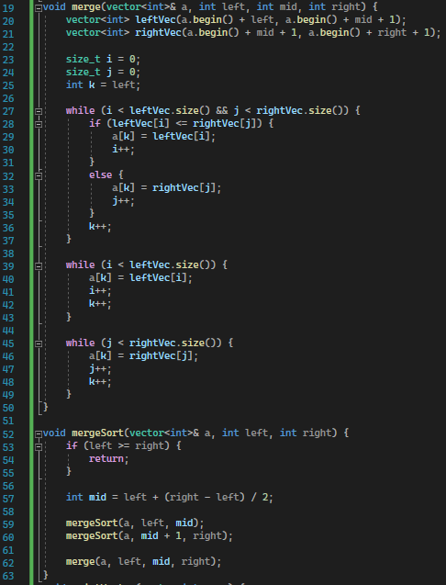
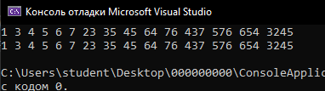
Сложность O(n*log(n))

